**CSIT5740 Fall 2024 Homework #2**

**Deadline: 11:55pm on Friday, 13 December 2024 (HKT)**

**Note:**

* **Submit the e-copy of your homework to**

**CSIT5740 Canvas->Assignment->Homework 2**

* **You can submit for as many times as needed before the deadline. Only the**

**latest version will be marked.**

* **Avoid submission in the last few minutes. NO late submissions will be accepted!**
* **Work out the answers of the questions either directly using this document. Paste proper picture as indicated. Zip this document together with your solve scripts into a single zip file “homework2.zip”. Make sure every detail of the answers is clearly visible in your submission, otherwise marks will be deducted.**
* **Make sure you download the file again to make sure you have really submitted the correct version**
* **Make sure you have a backup copy of the submission.**

**Name :**

**Student ID :**

**Email :**

|  |  |
| --- | --- |
| **Question** | **Points** |
| 1. **The Off-by-one vulnerability** | **/48** |
| 1. **The Address Sanitizer (ASAN)** | **/34** |
| 1. **The Same Origin Policy and Cookies** | **/18** |
| **Total** | **/100** |

**Question 1: The Off-by-One vulnerability (48 points)**

To make the exploitation possible, please make sure you turn off the Linux address space layout randomization (ASLR) protection. Otherwise the variable addresses will change every time you run the program. To turn off ASLR, you can do the following at the Kali prompt just like in HW1:

echo "0" |sudo tee /proc/sys/kernel/randomize_va_space

Again, make sure you are one of the “sudoers” that can sudo. If you are one of the students using our Kali virtual private server, then ALSR has been turned off by us already.

For this question, you are given a C program “HW2-Q1.c” and the corresponding executable “HW2-Q1”. Exploit the program so that it will give the shell. The program source code is provided to you on the next page. Note that in the program the shellcode has been given and stored in a global array **sc**. Your task is to refer to slides 20-31 of note set 4A, launch a similar off-by-one byte attack to the program so that it will run the shellcode stored. Note that different than all the previous questions you have seen, the only vulnerability exists in the given program is the off-by-one vulnerability that allows **overflowing the memory by one byte**.

#include <stdio.h>

#include <stdint.h>

#include <stdbool.h>

// the same 29-byte shellcode as in HW1 Q3

const uint8_t  __attribute__((section(".text#"))) sc[29] = {

    0x6a, 0x42, 0x58, 0xfe, 0xc4, 0x48, 0x99, 0x52, 0x48, 0xbf,

    0x2f, 0x62, 0x69, 0x6e, 0x2f, 0x2f, 0x73, 0x68, 0x57, 0x54,

    0x5e, 0x49, 0x89, 0xd0, 0x49, 0x89, 0xd2, 0x0f, 0x05

};

int i; // uninitialized global variable in the .bss section

char c; // uninitialized global variable in the .bss section

char input[32]; // uninitialized global variable in the .bss section

void copyInput(bool copy){

   char store[16];

   printf("Debug output:\n");

   printf("%p\n",sc);

   printf("%p\n\n",store);

   printf("Please provide the input string to be stored.\n");

   fgets(input,32,stdin); // no overflow is possible here

   if (copy==true){

      printf("copying inputs:\n");

      i=0;

      while (i<=16) { //off by one

         store[i]=input[i];

         i++;

      } // end while

   } // end if

} // end copuInput()

int main (void){

  bool copyOrNot = true;

   copyInput(copyOrNot);

}

We have supplied a compiled executable file, “HW2-Q1”, to you. Please use it to it to work on this question. It has been compiled with special flags to make this exploitation possible.

Before you can do anything, you need to give the “HW2-Q1” file the permission to run. To do that (make sure you are in the same folder as the file “HW2-Q1”), issue the following at Kali:

**chmod 705 HW2-Q1**

Then you can load “HW2-Q1” to gdb:

gdb ./HW2-Q1

After entering gdb, you can dis-assemble **main()** to see its instructions with the command “**disas main**” at the gdb prompt. And you will see the following:

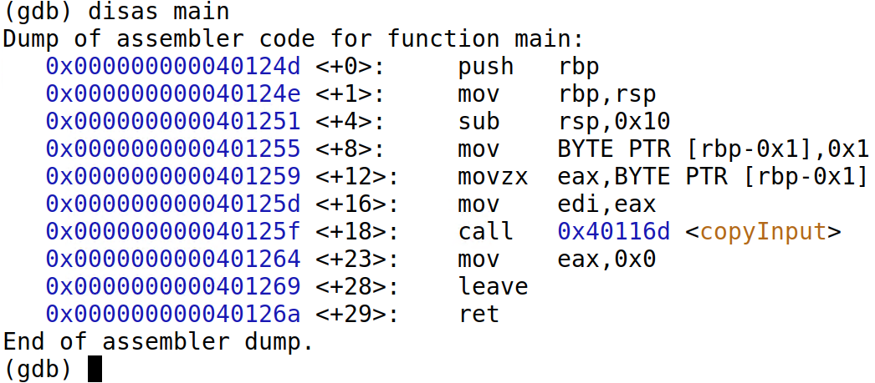

Fig. 1

Again, you may want to set gdb to display instructions in Intel format (but not AT&T format) if you see instructions in a different way than what is being shown here (i.e. if you see % symbols):

(gdb) set disassembly-flavor intel

Again you may want to put a break point to the main() function and then run the program:

(gdb) b main

(gdb) run

Then the program will stop at the beginning of main(), if you disas main() again you will see:

(gdb) disas main

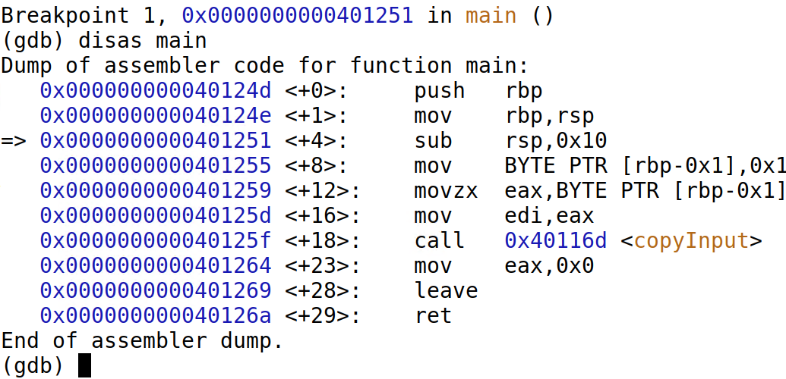

Fig. 2

Note from the above gdb dump that we will call function **copyInput()** at address 0x000000000040125f, and then we will return to the “**mov**” instruction at address 0x0000000000401264 (the address could be slightly different on your PC, but it should be the address of the same “**mov**” instruction). Remember this return address, it will help you. Now let’s check the function **copyInput()** that has the off-by-one vulnerability.

(gdb) disas copyInput

For simplicity, we are showing only the part that corresponds to the while loop (that contains the off-by-one vulnerability). The upper red rectangle in figure 3 indicates the beginning of the while loop, and the lower red rectangle indicates the last instruction of the loop

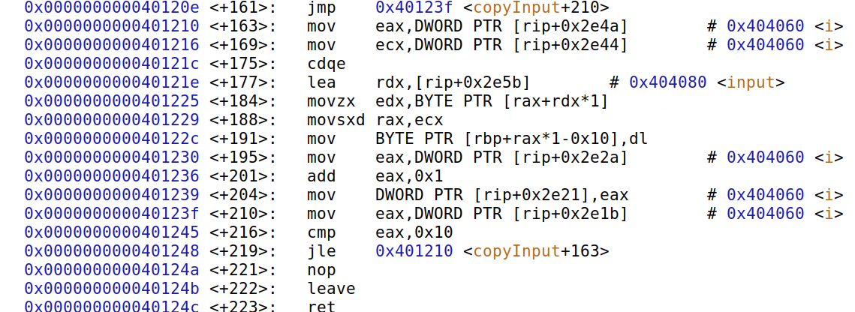

Fig. 3

Add a break point to the last instruction of the **copyInput()** function so that we can see the loop iteration by iteration and canknow how the characters are copied one by one to the stack **before** and **after** calling **gets()**.

Here we can add a break point to **0x0000000000401248** (“last instruction of the while loop, it will return back to the beginning of the while loop if the enough number of iterations has not been reached):

(gdb) b * 0x0000000000401248

Then continue to run the program using:

(gdb) c

Input seventeen A’s when the program prompts for input. The program will then stop at the break point 2 **(0x0000000000401248**)

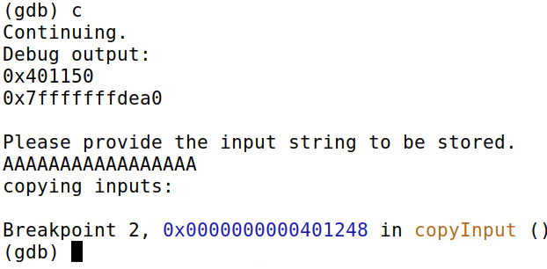

Fig. 4

That’s the point just *before* the **copyInput()**function and in this assembly code, no character has been copied to store[] yet. Continue to run the program using:

(gdb) c

The program stops again at breakpoint 2, That’s the point just *after* the **copyInput()**function has copied a single character to store[0].

Let’s e**X**amine **20** **w**ords from the top of the stack and show them in he**x** format:

(gdb) x/20wx $rsp

We see:

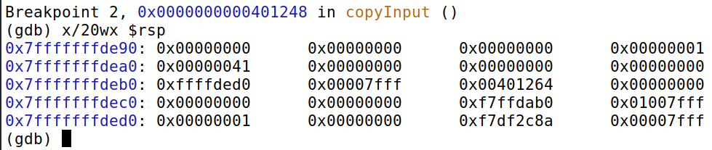

Fig. 5

Note that our first entered character “A” has been copied from input[] to store[] and is now visible ( at address 0x7ffffffffdea0, and this is where store[0] is located). Recall that the return address to get back to the **main()** is **0x0000000000401264** in figure 2. It is also enclosed by a red rectangle here. The red rectangle in figure 5 indicates where RIP is stored. We know from the lecture note that RBP is located immediately below RIP (RBP in figure 5 is underlined by a purple line). Our goal is to input values so that we can make the RBP to point to the beginning of store[] array, and we also put the **shellcode address** to the appropriate positions in the store[] array. In that way when getInput() returns to main() and then main() returns, the program will return to the shellcode address we put in the store[] array. Refer to slides 20-31 of note set 4A for all the details.

In other words, our target is to put characters to input[] array so that when it overflows the store[] array by one byte, it will overflow the lower byte of RBP appropriately, so that RBP points to the beginning of the store[] array. The lower byte of RBP is enclosed by a purple rectangle in Fig 6 below.



Fig. 6

a) By referring to the C source code HW2-Q1.c and by running the program HW2-Q1, determine the start address where the shellcode is located. Explain briefly in one sentence. **Enclose a screenshot showing the outputs of the program to support your answer**. (6 points)

b) Run the program HW2-Q1, use the output of the program to determine the address that the RBP should point to. Explain briefly in one sentence. **Enclose a screenshot showing the outputs of the program to support your answer**. (6 points)

c) By using the result of part (b), and by assuming that the start address of store[] different than the stored RBP only in the last byte (the rightmost byte), decide the **overflowed byte value** to be written to the memory so that RBP would point to store[]. Write the byte in hexadecimal format. **Explain the answer briefly in one sentence, otherwise no point will be given.** (6 points)

Note: in this example, the start address of store[] different than stored RBP only in the last byte. If the difference is more than 1 byte in a program, we may not be able to apply off-by-one technique directly.

d) Use a figure similar to Fig 6, calculate the amount of characters you have to input, if you want to reach the last byte of the stored RBP. Show your version of Fig 6 and show your calculation clearly otherwise no point will be given. (note: this value in fact does not need to be calculated if you know the principle of the off-by-one attack ☺ ),

(6 points)

e) With the result in (d), design a payload that will change RBP according to what you have derived in parts (c) and (d). You may use the character ‘A’ as padding. For example if your calculated result in part (d) is 11, and the answer in part (c) is 0x08, then you can write your answer as:

payload = AAAAAAAAAAA\x08

(8 points)

f) By referring to the lecture note set 4A slides 20-31, replace part of the payload in part (e) so that the appropriate part of store[] will be pointing to the shellcode address you have derived in part (a). Note that the address in part (a) should be 64-bit even if you may not see all the 64 bits from the output (i.e. left bits could be 0’s and are not displayed).

For example if you feel you need to put the shellcode address after three characters, and the shellcode address is at 0x00112233aabbccdd, then you can write your answer as:

payload = AAA\0xdd\0xcc\0xbb\xaa\x33\x22\x11\x00\x08

**Explain briefly why it is like that using the note set, otherwise no point will be given**. (8 points)

g) Use the compiled executable “HW2-Q1” we provided (make sure you give it the right to execute). Supply a proper payload, and run the shellcode. Show your full command below (include “**echo**” and everything). Enclose a screenshot to indicate that your exploitation is successful (see fig 9 below), for instance you can “ls” in it to see the files. **No point will be given if this screenshot is not included.**

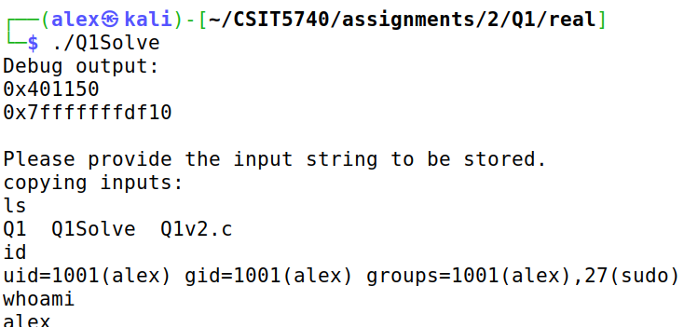

Fig. 7

Just like in HW1 Q3, Shellcode needs the input stream (stdin) before it can run. When stdin is unvailable, the shell will close immediately even if you manage to run it. You don’t really have to understand this, but to enable you getting the shell, your full command should be similar to the below:

**(echo -e "PAYLOAD_IN_PART_f" ; cat) | ./HW2-Q1**

Replace the **PAYLOAD_IN_PART_f** with the payload you have derived in part f.

(8 points)

**Question 2: The Address Sanitizer (ASAN) (34 points)**

The Address Sanitizer (ASAN) is a tool develop by Google to detect memory bugs. You may refer to note set 4C for the details of it.

Assume that the computer is a 32-bit system, assume that starting from the memory address **0x60FFFF18** 12 bytes of memory has been allocated to some variables in a **running program**.

a) By referring to slide 22 of the note set 4C, calculate the **memory block number** of the 12 bytes of allocated memory by filling out the following table. Assume that memory is divided into blocks of 8 bytes (i.e. 8 bytes per block). One of the fields has been filled for you. (5 points)

|  |  |
| --- | --- |
| **Memory address** | **Memory block number** |
| **0x60FFFF18** |  |
| **0x60FFFF19** |  |
| **0x60FFFF1A** |  |
| **0x60FFFF1B** |  |
| **0x60FFFF1C** |  |
| **0x60FFFF1D** |  |
| **0x60FFFF1E** |  |
| **0x60FFFF1F** |  |
| **0x60FFFF20** |  |
| **0x60FFFF21** | **0x0C1F FFE4** |
| **0x60FFFF22** |  |
| **0x60FFFF23** |  |

b) By referring to slide 17 of the note set 4C, calculate the **ASAN shadow memory addresses** for all the memory block(s) in part (a). Put one distinct memory block number in part (a) to occupy one row in the table. Put the corresponding shadow memory address at the right. A single entry (i.e. memory block number) has been filled for you. (3 points)

|  |  |
| --- | --- |
| **Memory block number** | **Shadow memory address** |
|  |  |
| **0x0C1FFFE4** |  |

c) Using the result from part (b), and slide 14 of the note set 4C, complete the following table. One row has been filled for you. (4 points)

|  |  |
| --- | --- |
| **Shadow memory address** | **Value stored** |
| **0x0C1FFFE3** | **0** |
|  |  |

d) Note that parts (a)-(c) all refers to the same program that is running and has ASAN turned on. Assume the same program is trying to **access 4 bytes of data** from the memory address **0x60FFFF1C**, will this memory access result in crash by ASAN)? Do the reasoning step by step.

i) The memory access is less than 8 bytes, so the following code of ASAN will be triggered (refer to the lecture note set 4C for the details of the code):

**ShadowAddr = (Addr >> 3) + Offset;  
  if ((*ShadowAddr != 0) && (*ShadowAddr-1 < ((Addr&7)+N-1))){  
     ReportAndCrash(Addr);**

**}else{             
        //...**

**}**

Derive the value of **ShadowAddr** in the above piece of code. Assume that when the program accesses the data, it will provide the starting address of the data (i.e. Addr = **0x60FFFF1C**). You may use the results from parts (a) and (b) to get the answer.

(2 points)

**ShadowAddr =**

ii) The **ShadowAddr** is in fact a pointer to a byte. The byte is storing the memory allocation information for a block of data memory. By referring to the table in part (c) derive **the value stored in** **ShadowAddr.** (2 points)

**\*ShadowAddr =**

iii) By assuming the data access size, **N**, to be **4** (4 bytes of data access), and by using the answers from part d(i), d(ii), decide whether this memory access would result in a crash by ASAN (i.e. will **ReportAndCrash(Addr)** be triggered)? Explain in 1-2 sentence(s) by using the code provided earlier. No point will be given if you just answer “Crash” or “No Crash”. (4 points)

e) This part refers to the same program as in part (d). Assume this time the program is trying to **access 4 bytes of data** from the memory address **0x60FFFF22**, will this memory access result in crash by ASAN)? Do the reasoning step by step.

i) The memory access is less than 8 bytes, so the following code of ASAN will be triggered (refer to the lecture note set 4C for the details of the code):

**ShadowAddr = (Addr >> 3) + Offset;  
  if ((*ShadowAddr != 0) && (*ShadowAddr-1 < ((Addr&7)+N-1))){  
     ReportAndCrash(Addr);**

**}else{             
        //...**

**}**

Derive the value of **ShadowAddr** in the above piece of code. Assume that when the program accesses the data, it will provide the starting address of the data (i.e. Addr = **0x60FFFF22**). You may use the results from parts (a) and (b) to get the answer.

(2 points)

**ShadowAddr =**

ii) By referring to the table in part (c) derive **the value stored in** **ShadowAddr.** (2 points)

**\*ShadowAddr =**

iii) By assuming the data access size, **N**, to be **4** (4 bytes of data access), and by using the answers from part e(i), e(ii), derive the following values. Show your steps clearly otherwise no point will be given. (4 points)

Note that the “**&**” operator below is a bitwise **AN**D operation. **Addr&7** will extract the lower 3 bits of Addr and return it as the answer.

**\*ShadowAddr - 1 =**

**(Addr&7) + N - 1 =**

Based on the above, explain whether this memory access would result in a crash by ASAN (i.e. will **ReportAndCrash(Addr)** be triggered). (6 points)

**Question 3: The Sample Original Policy and Cookies (18 points)**

Assume that the domain example.com is hosting two services, both are accessed through web browsers. First service is the website at <https://www.example.com>, and the second service is a mail service at <https://mail.example.com>.

a) Fill out the following table for example.com based on the **Same Origin Policy** in note set 5A. (10 points)

|  |  |  |
| --- | --- | --- |
| Origin 1 | Origin 2 | Origin 1 and 2 are of the same origin **Yes/No**? **Provide explanations. Otherwise not point will be given.** |
| https://www.example.com/ | http://www.example.com:443/ |  |
| https://www.example.com/pic.html | https://www.example.com/ |  |
| https://www.example.com | https://mail.example.com |  |
| https://www.example.com | https://example.com |  |
| https://www.example.com:80 | https://www.example.com |  |

b) If the server <https://mail.example.com> wants to set/send a cookie to its client (a web browser) and instructs the client to send the cookie back **only to the mail server** and through **https**. The cookie also **shouldn’t be accessed by any Javascript code**. Fill out the following for the correct cookie values. Whenever appropriate use “true” or “false” to indicate logical values. (4 points).

Cookie:

User = CSIT5740_user;

Domain = _______________________ ;

Secure= ________________________;

c) If the host at <https://mail.example.com> sets the cookie sent to a client with:

Domain = example.com

Path = /imap

which of the following hosts would the client send the above cookie? Example briefly for each case, other no point will be given. (4 points)

i) [http://mail.example.com/](http://mail.example.com/imap)

ii) <https://www.example.com/imap>

iii) <https://mail.anothersite.com>

iv) <http://user1.example.com/imap/v2.0/>